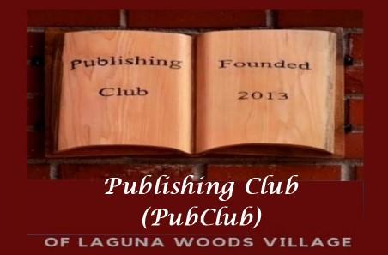

Dear Sponsor,

The Publishing Club of Laguna Woods Village (PubClub) is very excited to host our Spring Author Forum on April 19 at Clubhouse 7, from 6-8 PM. This event will showcase our talented members promoting and offering for sale books they have written in a variety of genres.

Here are the details…

Sponsorship levels are as follows:
- Title and Gold Sponsorship contributions of $500 or more will receive:
- a full-page advertisement in a prime location in our Author Forum booklet distributed to all invitees
- your name in any advertising in The Globe, on TV6, and social media
- a table inside Clubhouse 7 during the Author Forum where you can promote your business
- free one year PubClub membership, including copy of current Village Stories
- Silver Sponsorship contributions of $250 will receive:
- a half page advertisement in our Author Forum booklet distributed to all invitees
- your name in any advertising in The Globe, on TV6 and through social media
- free one year PubClub membership, including copy of current Village Stories
- Bronze Sponsorship contributions of $250 or less will receive:
- your name listed in our Author Forum booklet distributed to all invitees
- free one year PubClub membership, including copy of current Village Stories
For further information, contact us at pubclublw@gmail.com or call Marla Stone at (949) 709-7000. Thanks for your consideration!

The PubClub of Laguna Woods Village

